ICTWEB501

## Assessment Task 3

# Testing Document for website

# Downhill Downder

*Author:* Alessandro Ferro

Introduction

**Purpose**

The purpose of this document is to record the testing effectuated on the Downhill Downunder website, to ensure that the requirements have been met and that the website has been devveloped according to the standards and the expectations of the client.

The results of the testing would serve as the basis for the accetance or the rejection of the final product by the client.

**Scope**

The testing outlined in this document has been designed and agreed upon by the client and by the developer. The testing has been conducted in the development environment, using the xampp stack to resemble as closely as possible the website production environment.

The testing will cover: link check, cross-browser compatibility, functionalities and error handling.

Link Check

The website relies on a number of internal and external links.

Internal links allow the user to navigate between the various pages of the website, while external links provide the website with resources from other applications.

The link check is done to ensure that there are no broken link in any of the pages. Broken links would lead the users to error pages and would compromise the credibility and the reputation of the client, on top of resulting in bad user experience.

Cross-Browser Compatibility

The website has been designed and developed to ensure consistent rendering between all the major web browser. The technologies adopted and their implementation followed all the modern standard and practices, including the use of languages, tags, libraries and APIs supported by most browser.

Cross-browser compatibility is tested by accessing the website through different browser, visually checking that all the elements have been rendered in line with the original design and layout.

Functionalities

The bulk of this document describes the testing of the behaviour of the website in relation to the interactions of the users with the system. The website functionalities include both client side and server side operations, to perform data validation, DOM manipulation, CRUD capabilities, shopping cart and checkout. The server side also handle connection and querying of the database.

The functionalities have been defined, refined and agreed upon by the client and the developer.

Each functionality has been tested manually, using ad-hoc dummy data. The result of each test has been checked against the expected result to determine success or failure of the test.

Error Handling

Users input can be inconsistent with the parameters accepted to the system, leading to errors. All the forms and the element that allow a user to enter data into the system have been developed to notify the user of the error and to allow the user to correct it, without breaking the website.

The tests have been conducted by purposedly entering invalid data and visually checking how the website reacts.

**User of the System**

Unregistered user

Unregistered users can navigate the website and browse the products, but they cannot access the shopping cart

Regitered customer

Registered customers have access to a profile and can add and remove items from their shopping cart. They can also checkout and pay through paypal.

Admin

Admin has access to the admin dashboard to manage (CRUD) users, categories and products. They also have sales charts and reports available on their dashboard.

Link Check

Method used: npm broken link checker

* Run command

$ blc http://localhost:81/ICTWEB501_alessandro_website/ -ro \ --exclude bower_components \ exclude build \ exclude database \ exclude dist \ exclude images \ exclude magnify \ exclude plugins \ exclude vendor



* Results from root directory

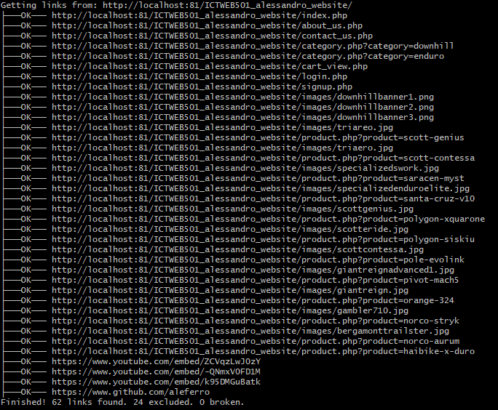

1. Cross Browser compatibility

** The images in the home page may vary due to the banner carousel**

**Home Page**

Chrome

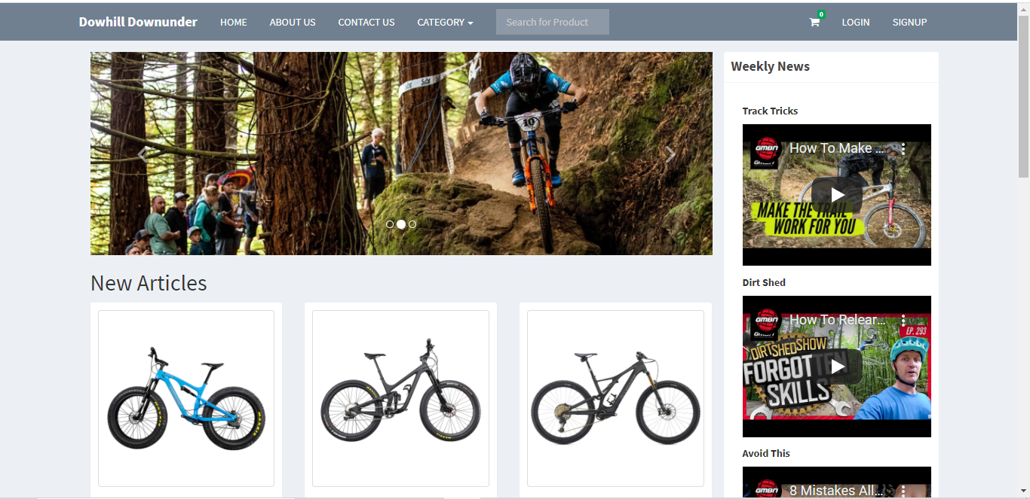

Edge

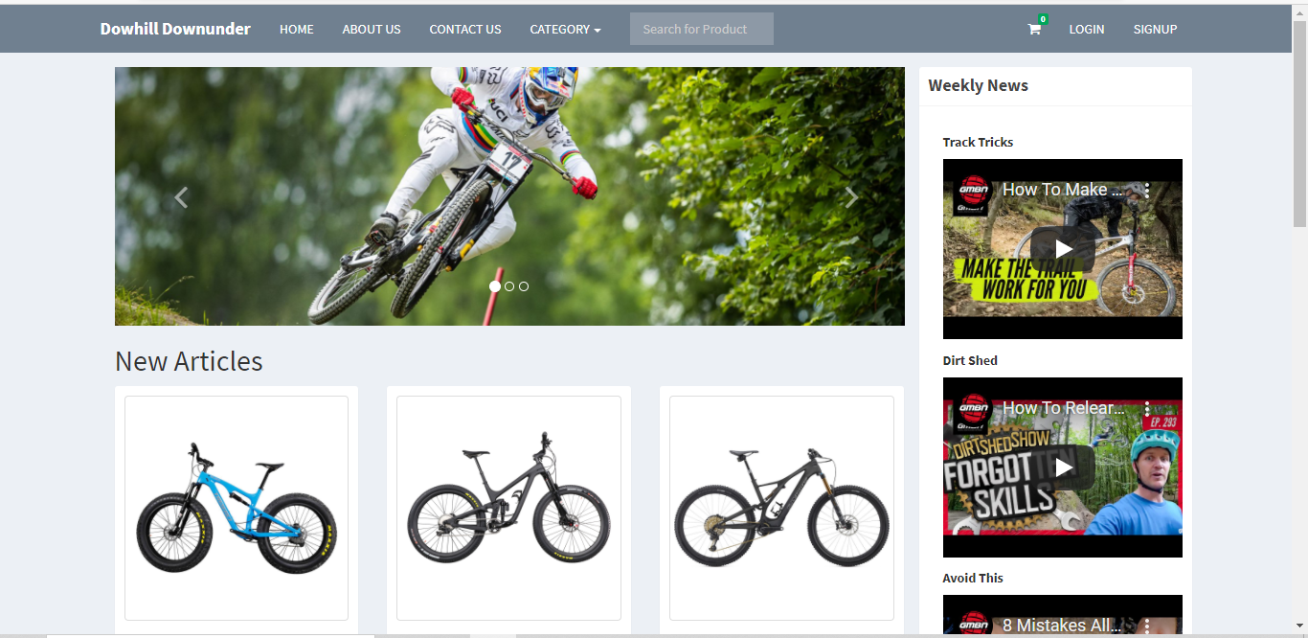

Firefox

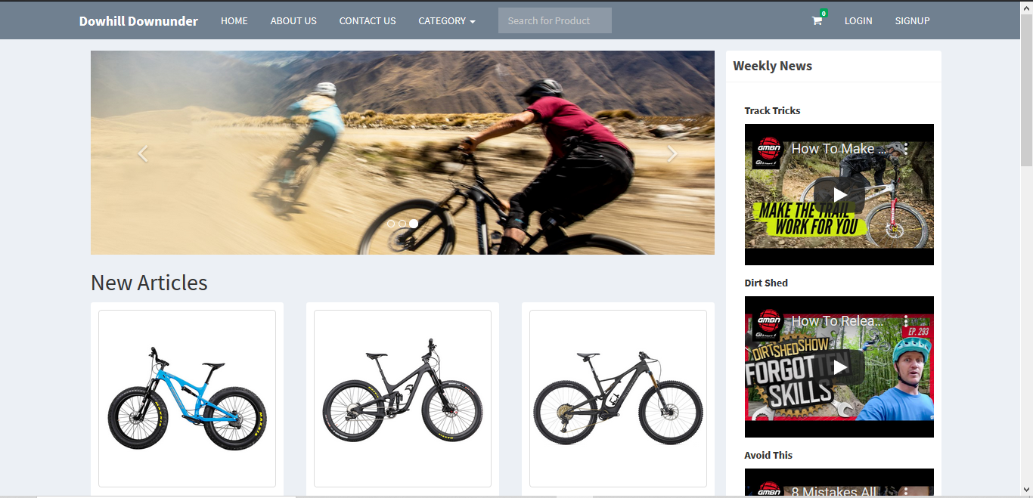

**About Us Page**

Chrome

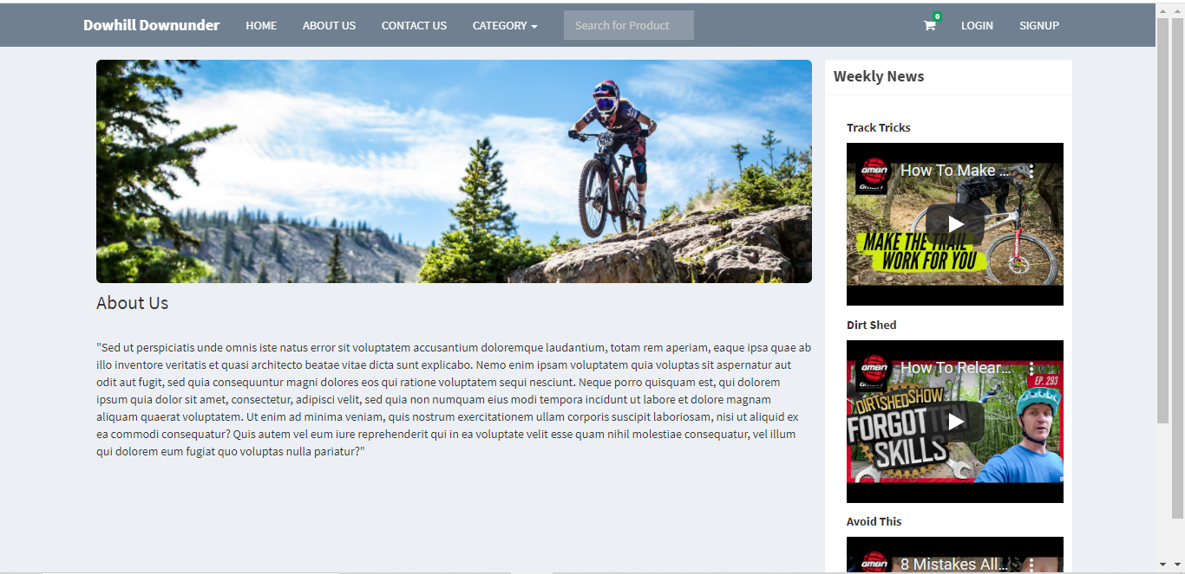

Edge

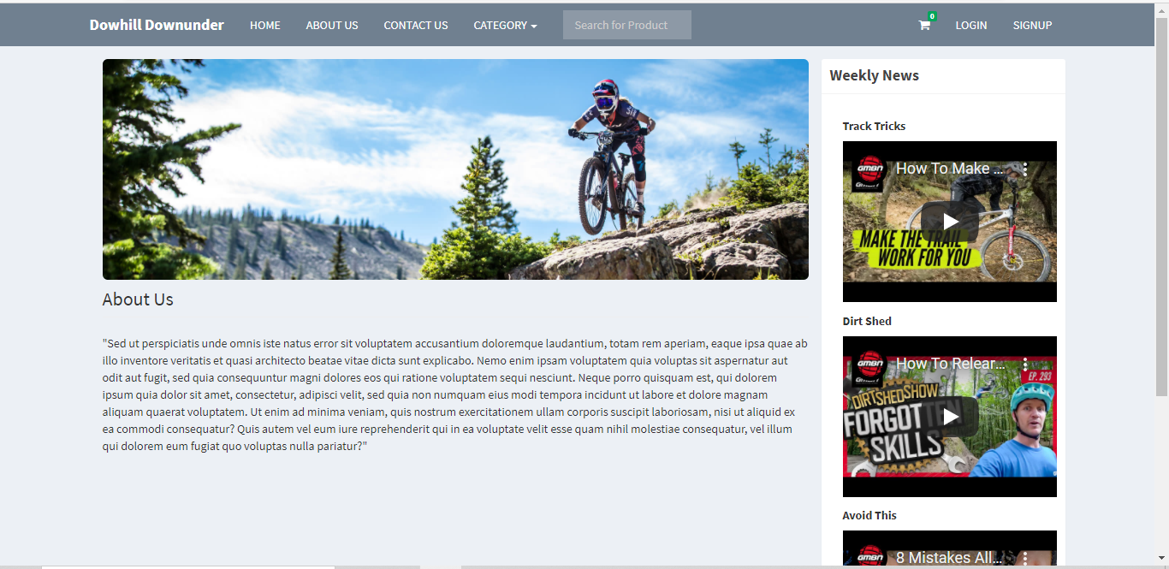

Firefox

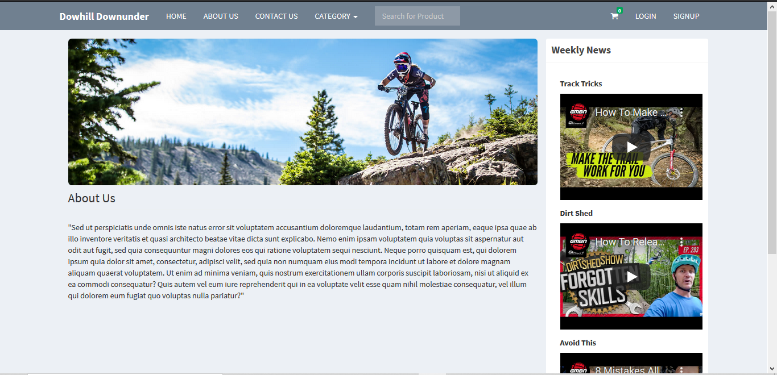

**Contact Us**

Chrome

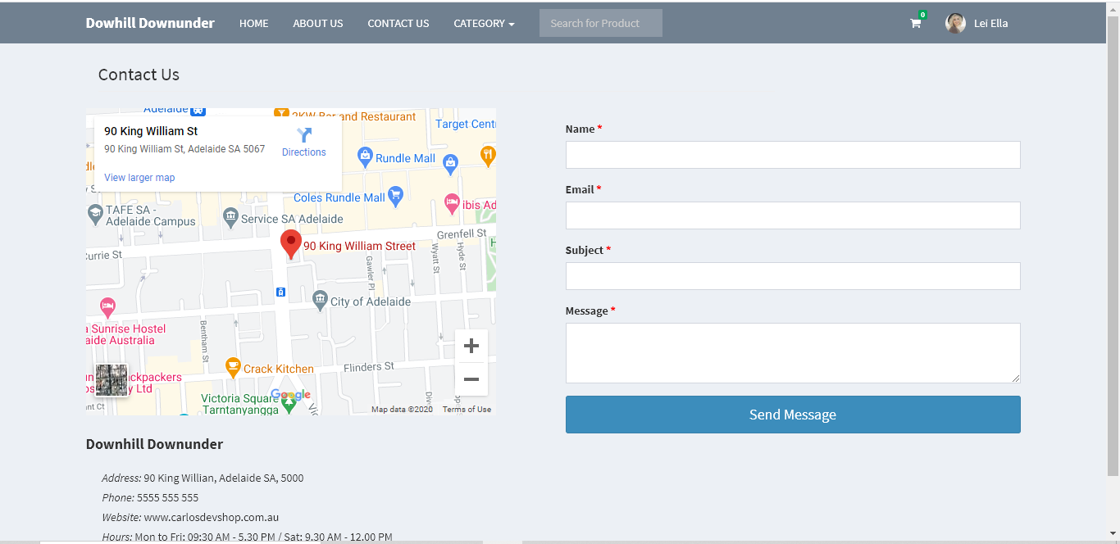

Edge

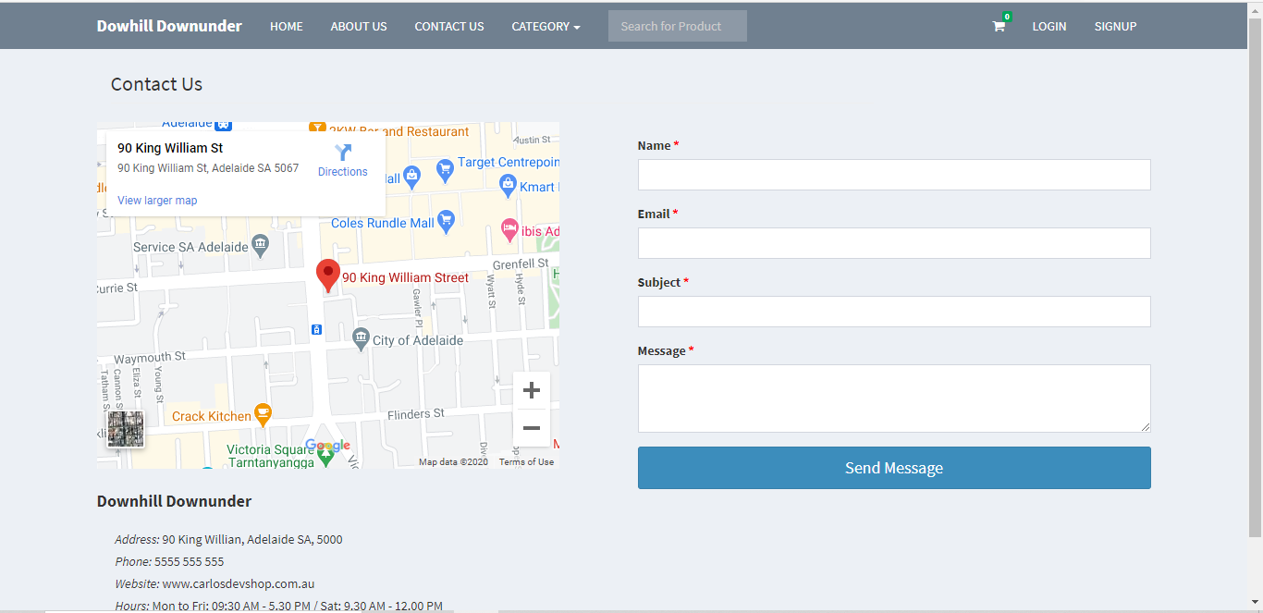

Firefox

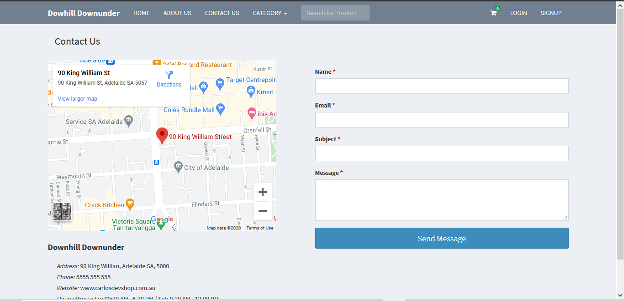

**Categories: Downhill**

Chrome

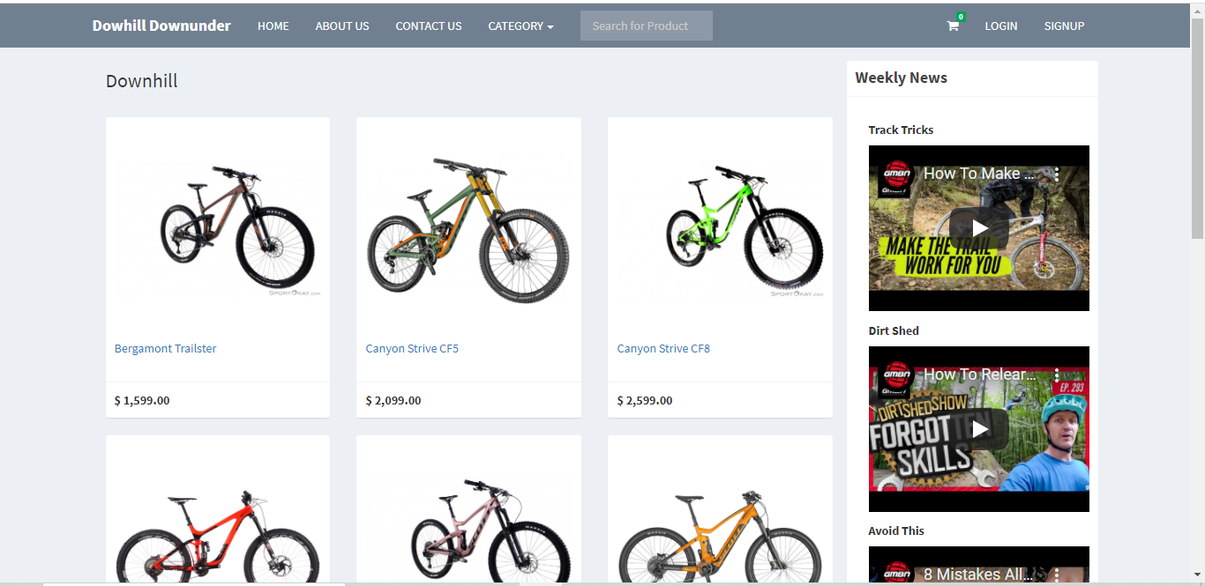

Edge

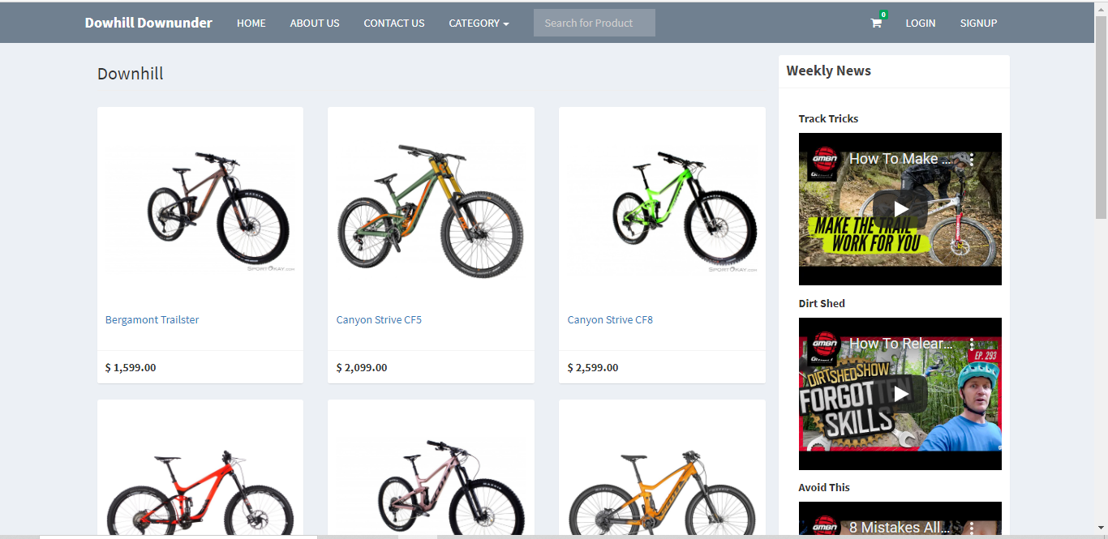

Firefox

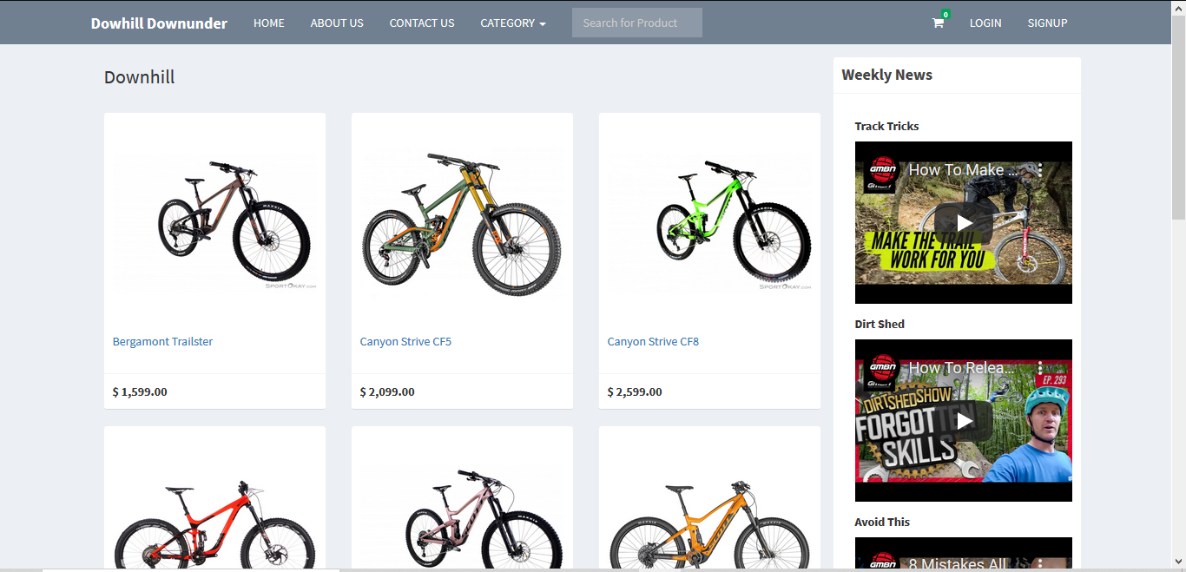

**Category: Enduo**

Chrome

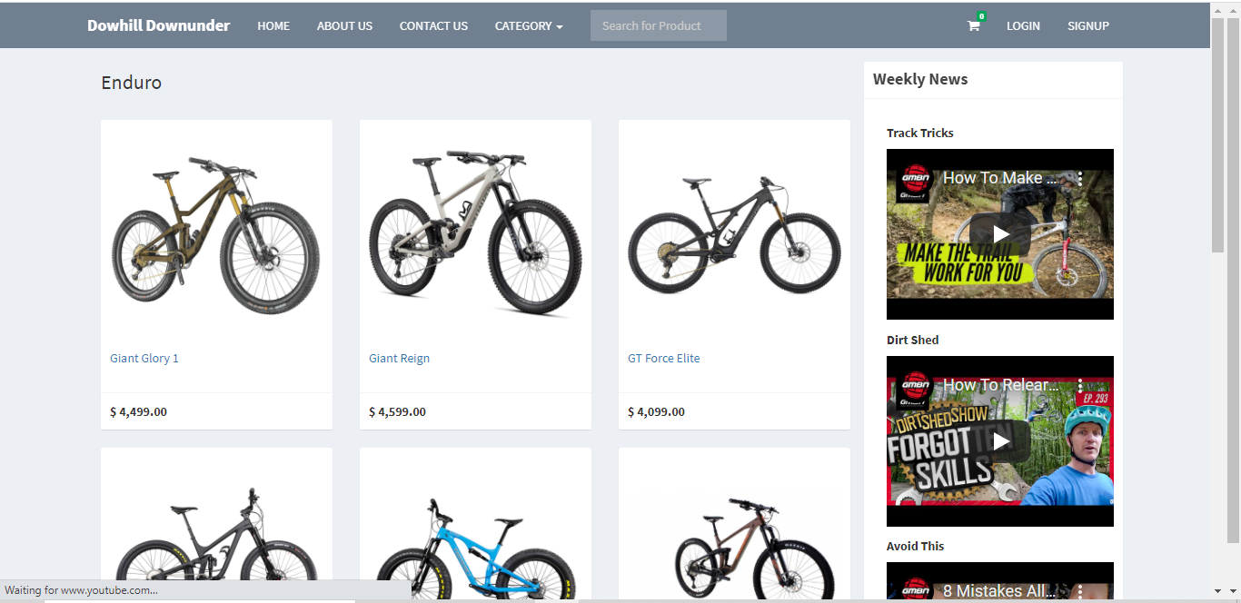

Edge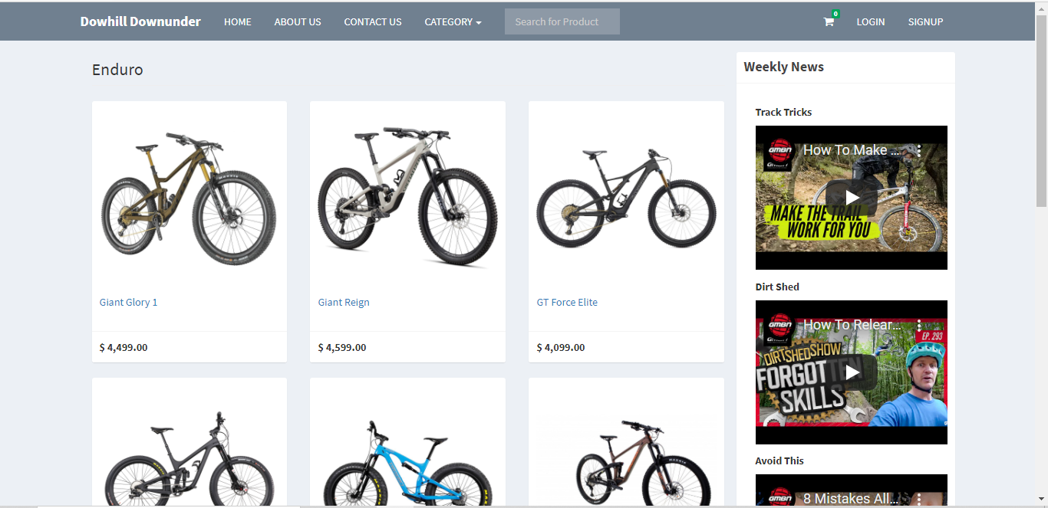

Firefox

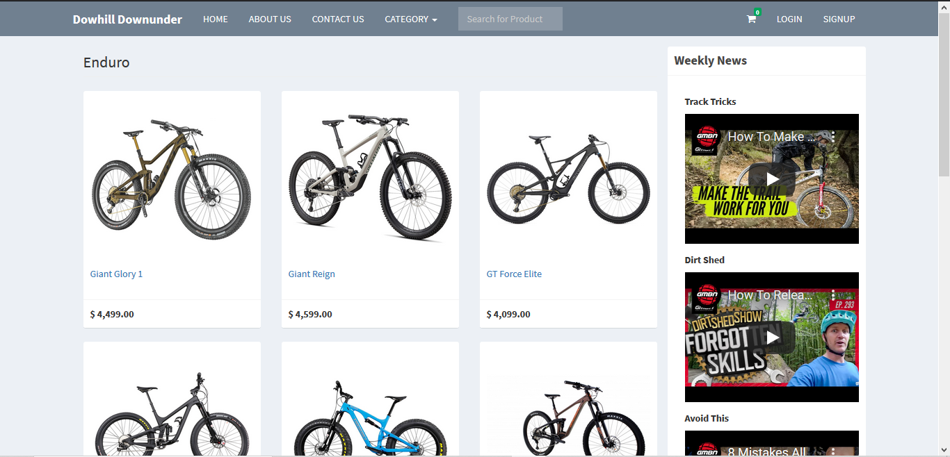

**Product Page**

Chrome

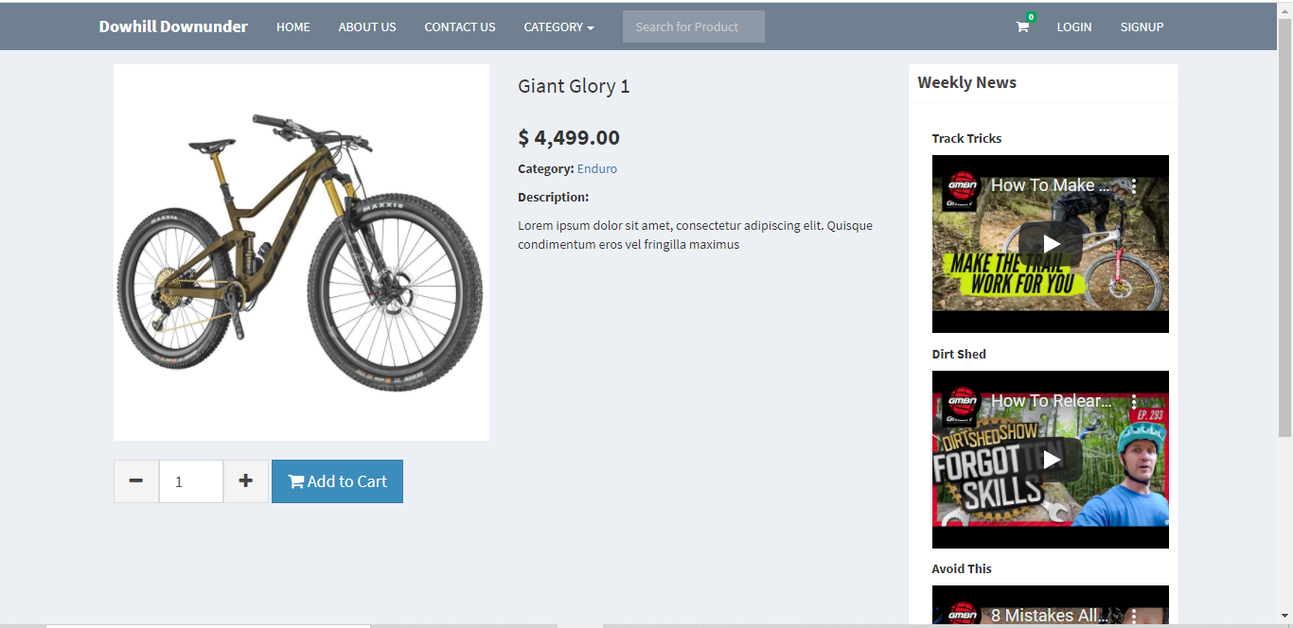

Edge

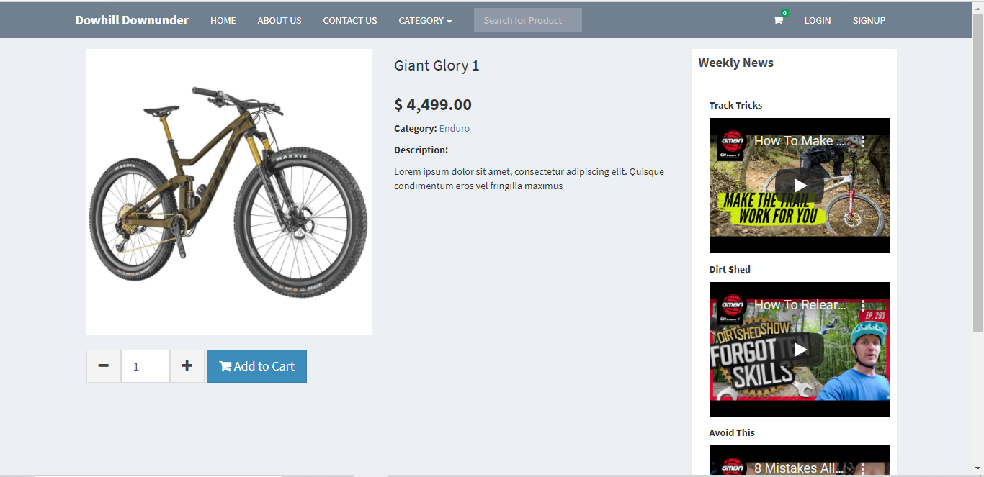

Firefox

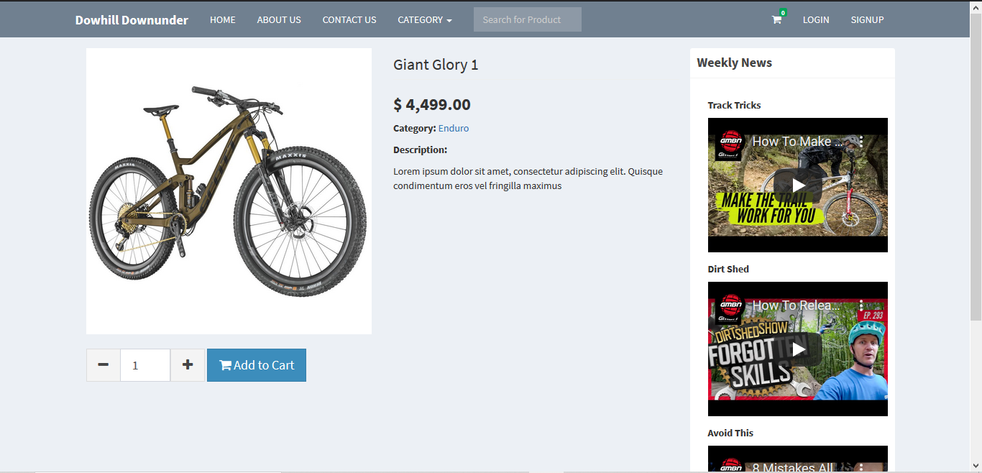

**Shopping Cart Page**

Chrome

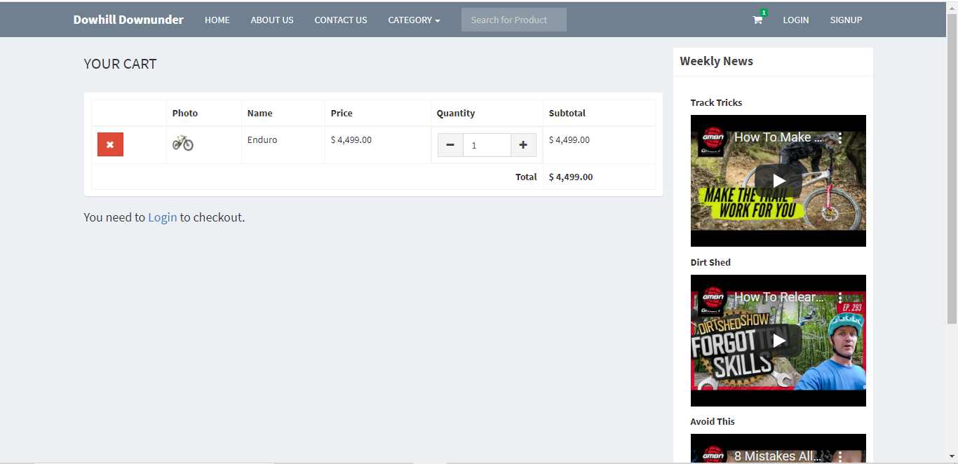

Edge

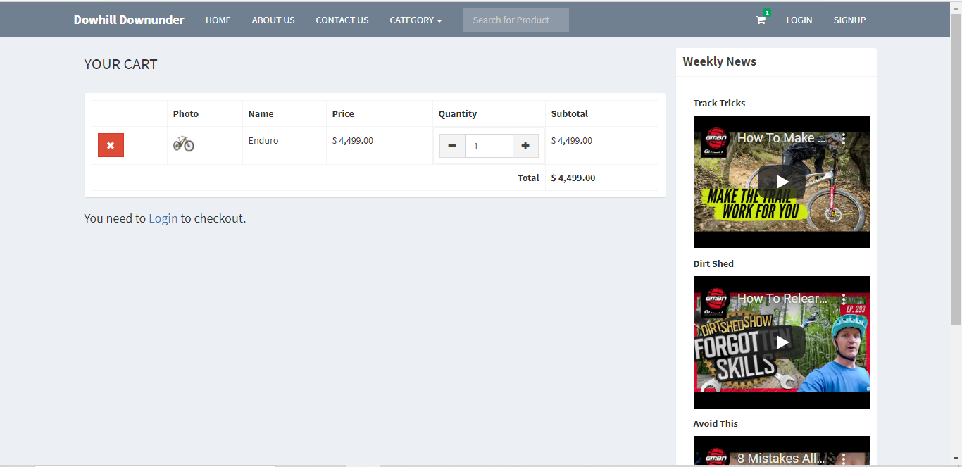

Firefox

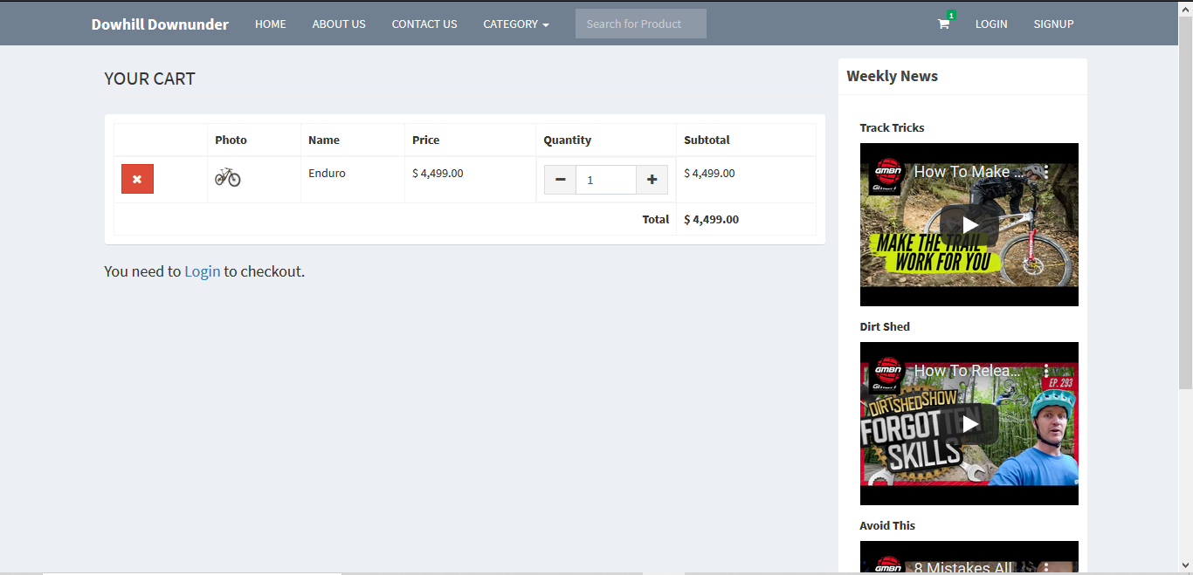

**Login Modal**

|  |  |  |
| --- | --- | --- |
| Chrome | Edge | Firefox |
|  |  |  |

**Sign Up Modal**

|  |  |  |
| --- | --- | --- |
| Chrome | Edge | Firefox |
|  |  |  |

**Admin Dash**

Chrome

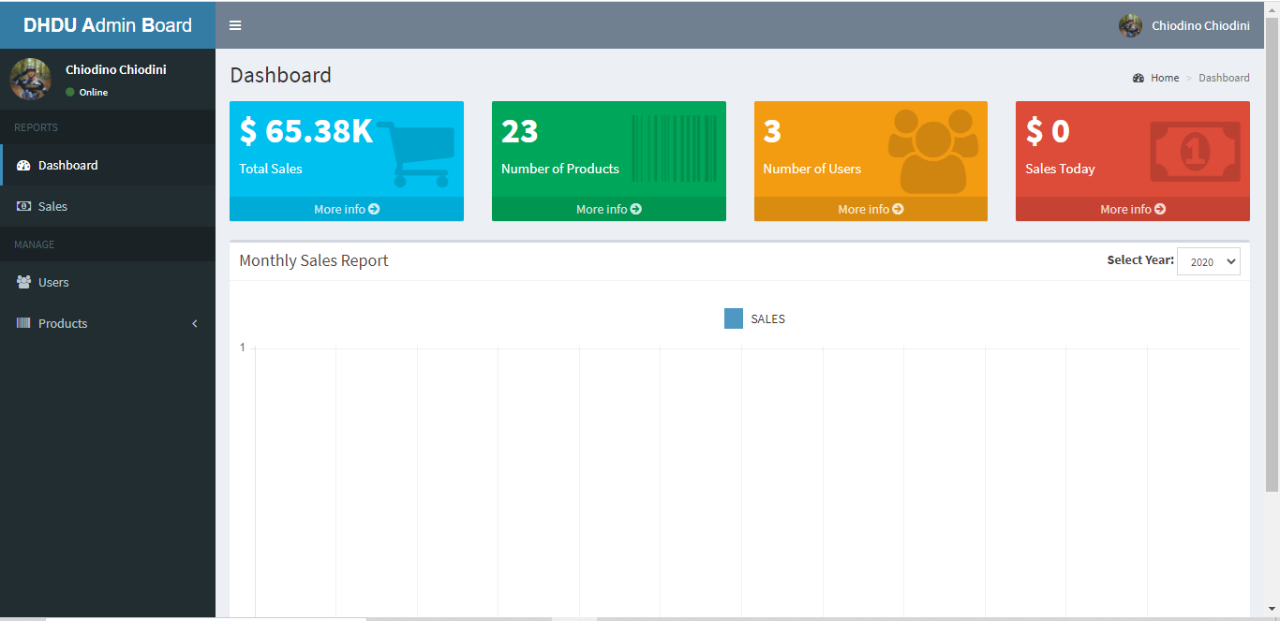

Edge

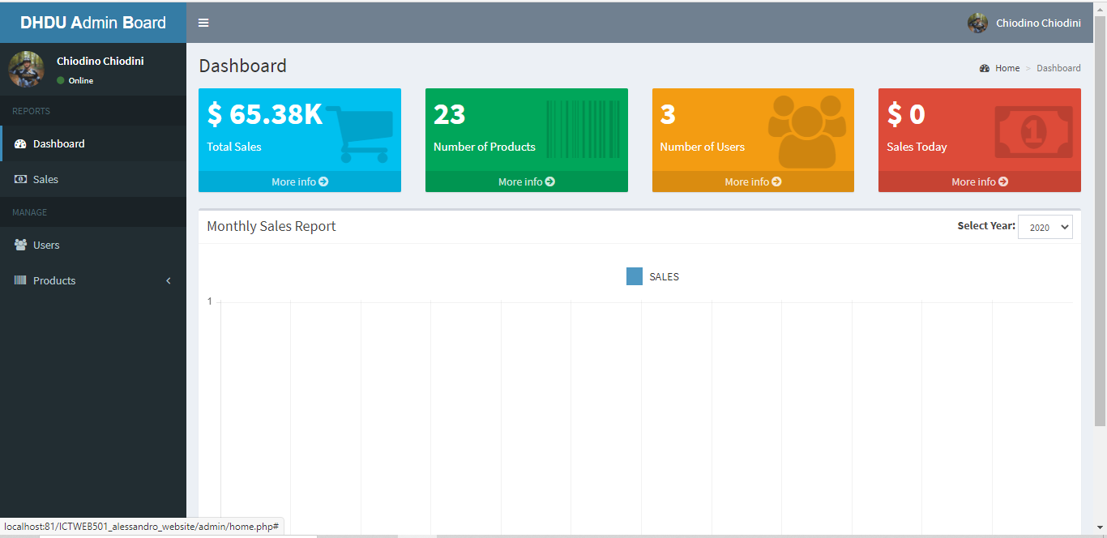

Firefox

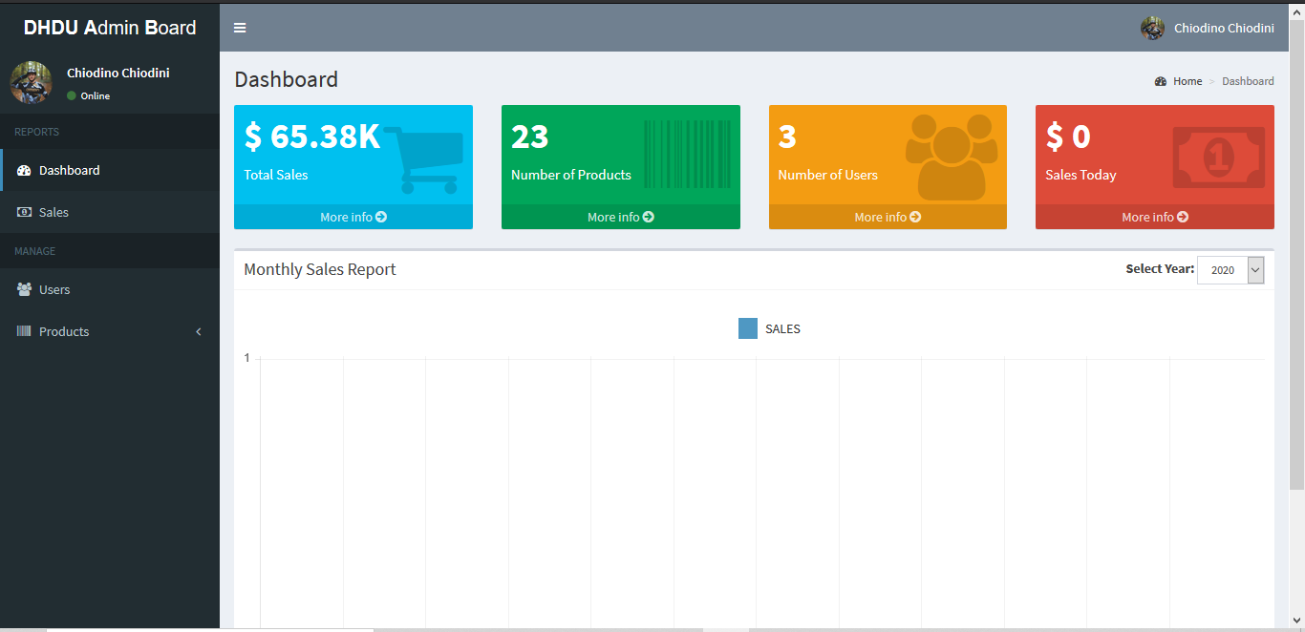

Functionalities

**Login**

|  |
| --- |
|  |
| **Arrow Straight**  Click ‘Sign in’ |
|  |

**Sign up**

|  |  |  |
| --- | --- | --- |
|  | **Arrow Straight**  Click ‘Sign up’ |  |

**Add to Cart**

|  |
| --- |
|  |
| **Arrow Straight**  Click ‘Add to Cart’ |
|  |

**Add to Cart – Shopping cart**

|  |
| --- |
|  |
| **Arrow Straight**  Click ‘Go to Cart’ |
|  |

**Remove from Shopping Cart**

|  |
| --- |
|  |
| **Arrow Straight**  Click red and white X |
|  |

**Paypal**

|  |  |  |
| --- | --- | --- |
|  | **Arrow Straight**  Click ‘Pay by Debit or Credit Card’ |  |

**Send message (Contact Us Page)**

|  |  |  |
| --- | --- | --- |
|  | **Arrow Straight**  Click ‘Send Message’ |  |

**Search Product**

|  |
| --- |
|  |
| **Arrow Straight**  Press ‘Enter’ |
| **Sales (Admin Dashboard)**    **Sales Details (Admin Dashboard)**    **Users (Admin Dashboard)**    **View User Cart (Admin Dashboard)**    **Edit Quantity**   |  |  |  | | --- | --- | --- | |  | **Arrow Straight** |  | |

**Delete from User’s Cart (Admin Dashboard)**

|  |  |  |
| --- | --- | --- |
|  | **Arrow Straight** |  |

**Add Product to User’s Cart (Admin Dashboard)**

|  |  |  |
| --- | --- | --- |
|  | **Arrow Straight** |  |

**Edit User (Admin Dashboard)**

|  |
| --- |
|  |
| **Arrow Straight** |
|  |

**Delete User (Admin Dashboard)**

|  |
| --- |
|  |
| **Arrow Straight** |
|  |

**Add New User (Admin Dashboard)**

|  |
| --- |
|  |
| **Arrow Straight** |
|  |

**Product List (Admin Dashboard)**

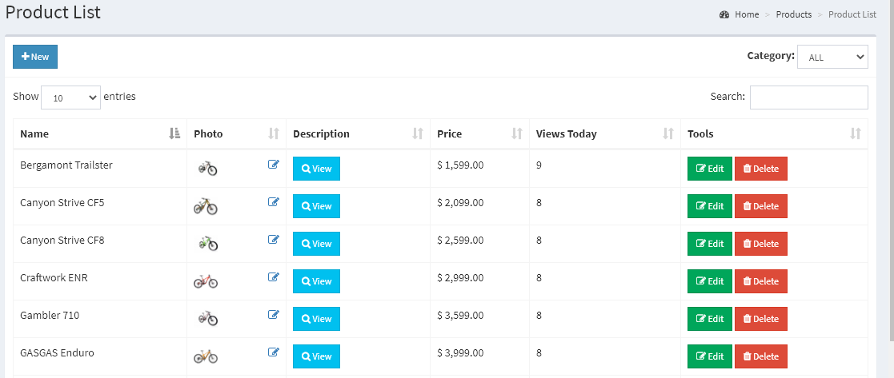

**View Description (Admin Dashboard)**

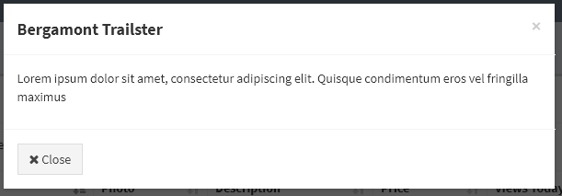

**Add new Product (Admin Dashboard)**

|  |
| --- |
|  |
| **Arrow Straight** |
|  |

**Edit Bike (Admin Dashboard)**

|  |
| --- |
|  |
| **Arrow Straight** |
|  |

**Delete Product (Admin Dashboard)**

|  |
| --- |
|  |
| **Arrow Straight** |
|  |

**Category (Admin Dashboard)**

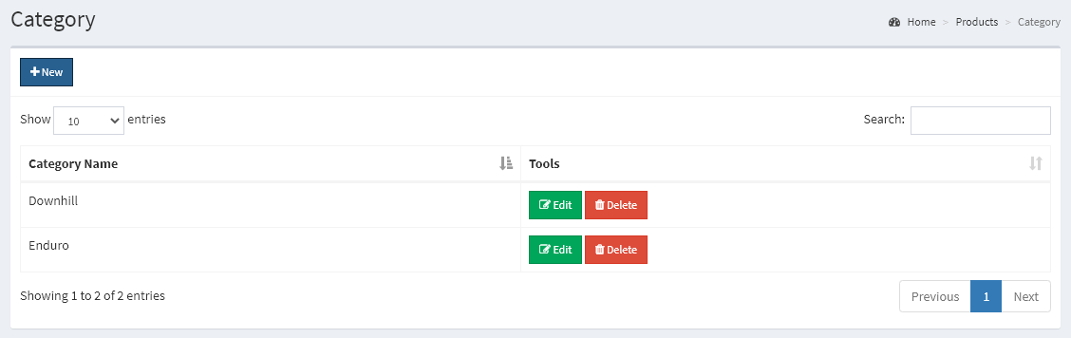

**Add Category (Admin Dashboard)**

|  |
| --- |
|  |
| **Arrow Straight** |
|  |

**Edit Category (Admin Dashboard)**

|  |
| --- |
|  |
| **Arrow Straight** |
|  |

**Delete Category (Admin Dashboard)**

|  |
| --- |
|  |
| **Arrow Straight** |
|  |

Error Handling

**Sign up**

* Email already taken

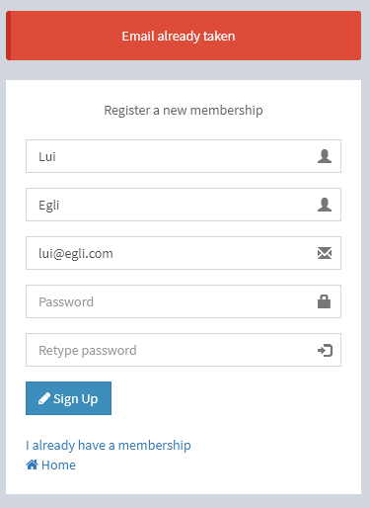

**Login**

* Invalid password

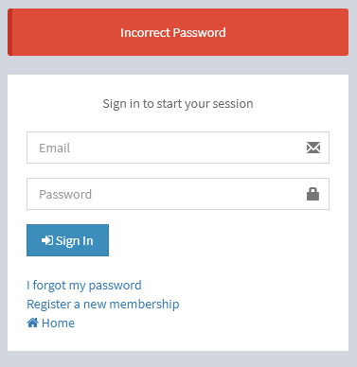

**Contact us**

* Message cannot be sent

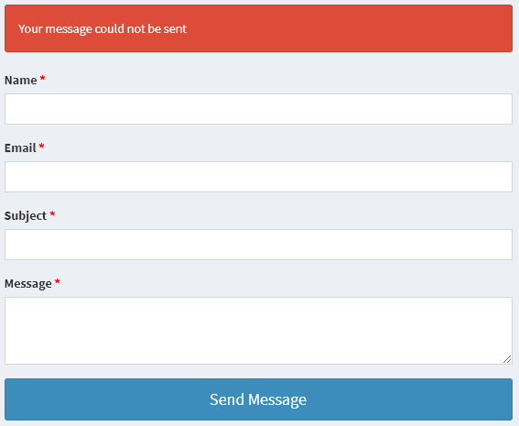

Conclusion

The testing of the Downhill Downunder website didn’t result in any outstanding error and completely fulfill the requirements of the client.

The link check returned with a result of zero broken links in all the application.When running the program, some files have been left out. Those file include images, assets or libraries that do not contain any code and the purpose of their omission is to speed up the testing progress. Their exclusion doesn’t affect the result of the test.

Cross browser compatibility testing shows a consistent rendering of the website in the browser taken in consideration for the testing. The browser are Chrome, Edge and Firefox and are currently the most used world-wide, indicating that the website is potentially accessible by most people in the world. To ensure that the results are relevant, every page of the website has been tested.

The functionalities have been tested manually by running them with dummmy data, simulating a user interaction with the application. All the functionalities behaved as expected, according to the user authentication and authority level and in line with the performance required by the client.

The possibility of human error when interacting with the system is accounted for. Errors don’t compromise the user experience, are clearly signaled and the user can act on them immediately without needing any extra navigation.

In conclusion the Downhill Downunder website is considered completed and ready for hand-off to the client.